

AAD531

Assessment - 1



April 8, 2021

prapti mane

Student No – 13491449

Table of Contents

Inspiration 2

Logo (Kayla Jolly Hairdresser) 4

Home Page 6

About Kayla Page 7

Services Page 7

My Work Page 8

Contact Page 9

Evolving Design 10

Image 11

Typography 12

Composition 12

Final Design 13

Copy 13

Home Page 14

Portfolio Page 15

Services Page 16

Sign-up Page 17

Contact Us Page 18

Splash Page 19

Future 19

References 19

# Inspiration

I did a competitive analysis for the Kayla Jolly Hairdresser website in my first year. Although none of those websites had a splash page, I had seen some splash pages on some websites., and after googling and you tubing, I came across this idea of the splash page. The inspiration behind this splash page came from the fact that I wanted to have a cool feature on the website to enter it and that is exactly what I found on YouTube.

As far as the website is concerned, I have spoken to the client and discussed the colors, the Kayla Jolly Hairdresser website is about as the name suggests a hairdressing website. The main purpose of the website is to help Kayla Jolly to establish herself as a brand. Which will help her get new clients and help her current clientele book appointments on the website. The website will also be used for Kayla Jolly to showcase the services and their costs and post her work too.

Some of the websites that I believe can be considered competition are :-

<https://www.vivo.co.nz/>

<https://www.abokihair.co.nz/>

These are some of the Hairdressers in Nelson New Zealand. I have gone through both these websites, they’re very good but I still find them slightly busy layout wise especially the Vivo website as it has too much information on it’s website, it’s not easy on the eyes.

Aboki on the other hand has the right amount of information but their brand colors hurt my eyes every time I look at the website. It is a little too much.

The website that I really liked and still like is the Cardells Hair website <http://www.cardells.co.nz/>. This website has almost the same colors as the Kayla Jolly brand hence it does make it easy to visualize the Kayla Jolly Website.

Below is the screenshots of what I like about the Cardells Hair website.

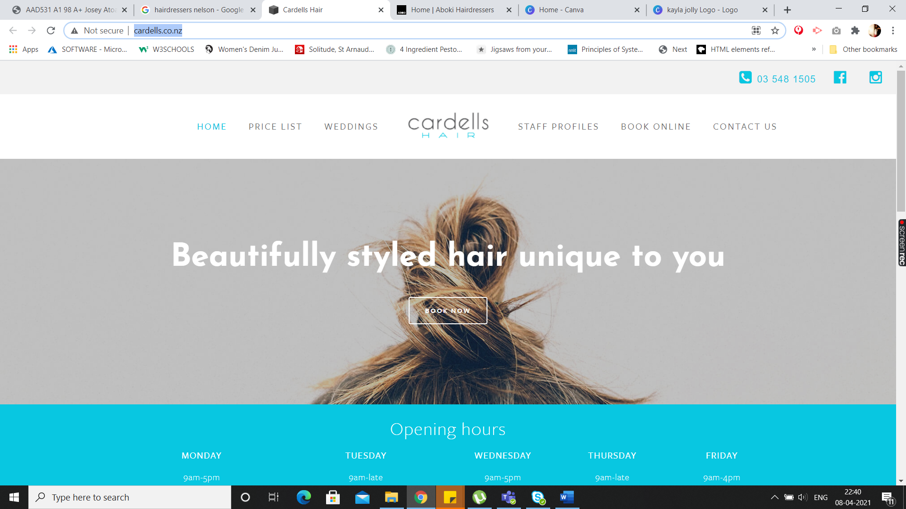

I like how the home page also shows the Opening Hours in the first fold of the website page. The layout is very simple and good to look at. The navigation is basic and to the point.

I have worked on the Kayla Jolly Hairdresser website in my first year, as Kayla Jolly is my partner by the end of my degree, I want to have atleast a final template of the website it’s look and feel, so I can go ahead and build it in Squarespace and make it live.

The logo of the brand will always be the same that is something which is approved by the client and so are the colors.

## Logo (Kayla Jolly Hairdresser)

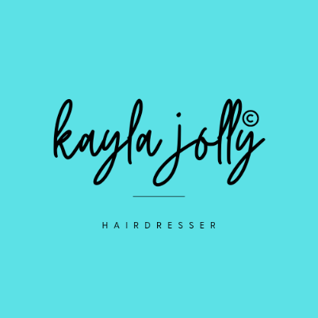

This is the new logo for the brand as the old logo was very basic and did not match the personality of the brand, hence we decided to get something modern hence I designed this logo using Canva, my go to tool in most unpaid design jobs.

Below are the screenshots of the website I created in my first year using HTML and CSS, I am still quite proud of the layout and colors, but now I have decided to make it a bit more modern since this was 2 years ago.

## Home Page

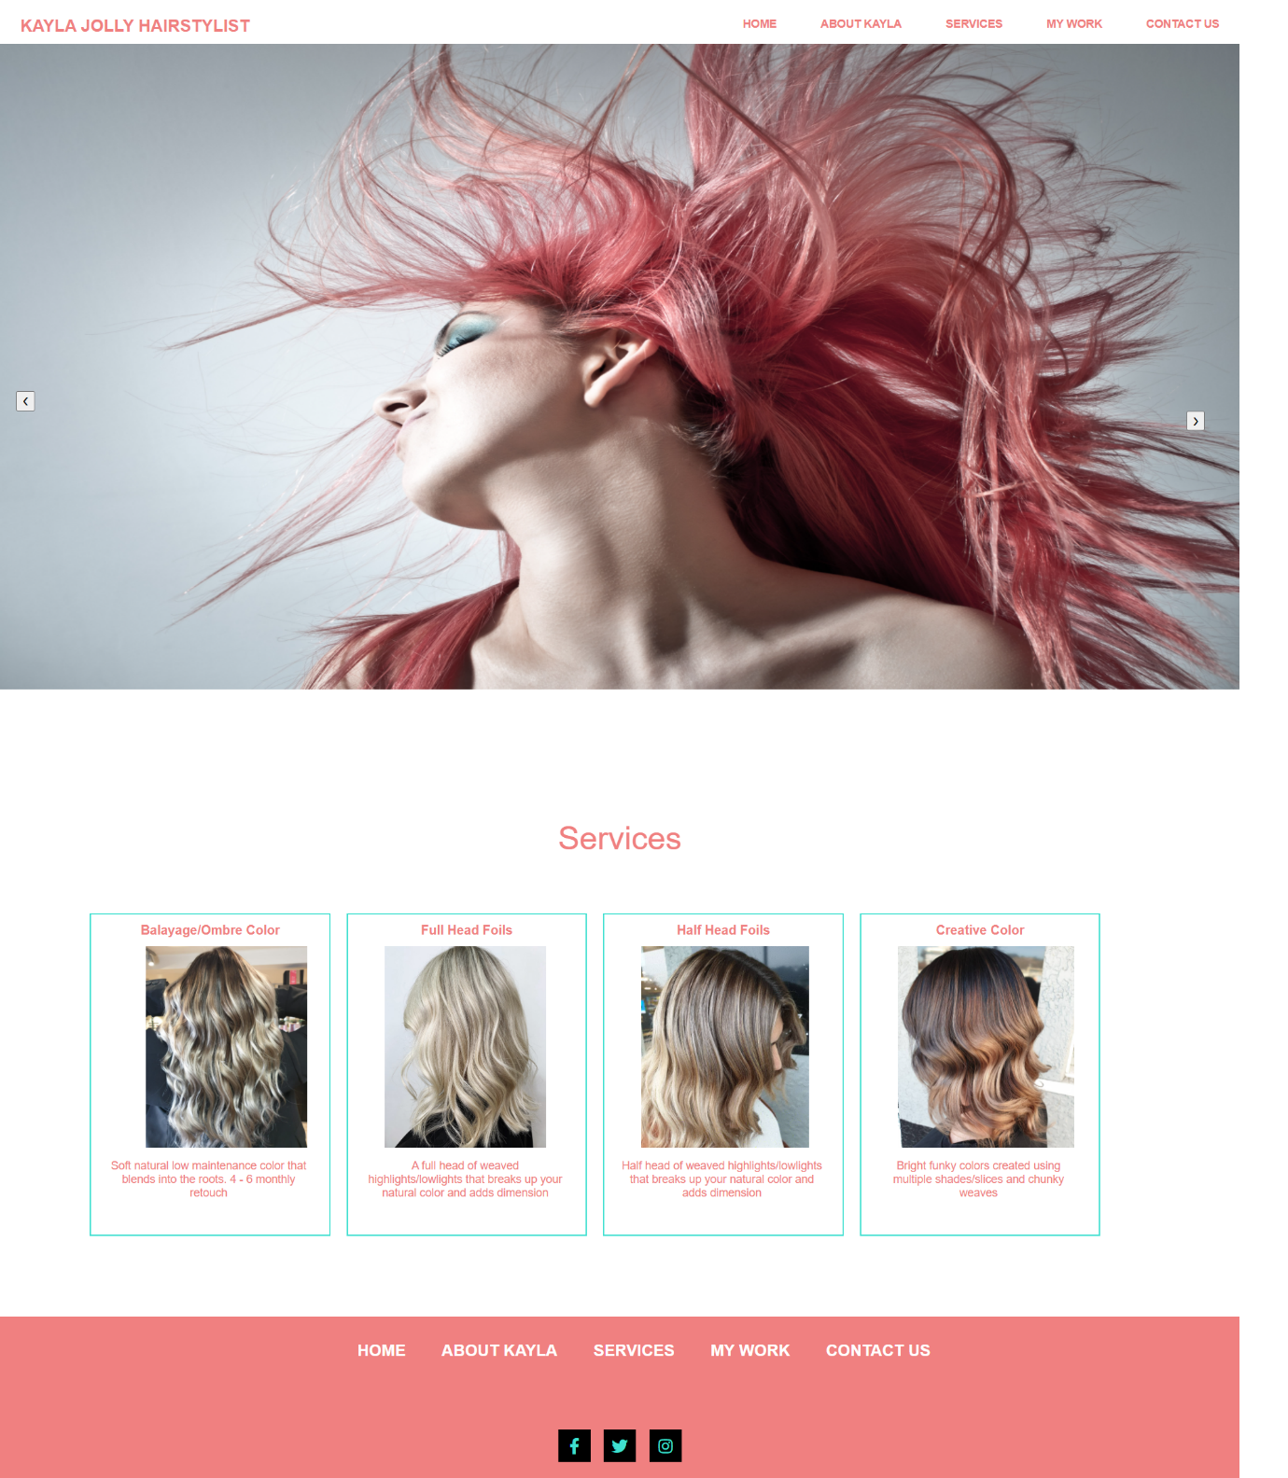

As you can see the colors I have used are Pink, Turquoise on white background. I have decided to keep the colors the same but add more turquoise to the website. I have also decided to change the logo for the website and use the new logo instead. The client has decided to change the brand name from Kayla Jolly Hairstylist to Kayla Jolly Hairdresser.

The hero image and the other images will be the same on the website, as some of them are downloaded from Unsplash whereas the hair images are the images supplied by the client of her work.

## About Kayla Page

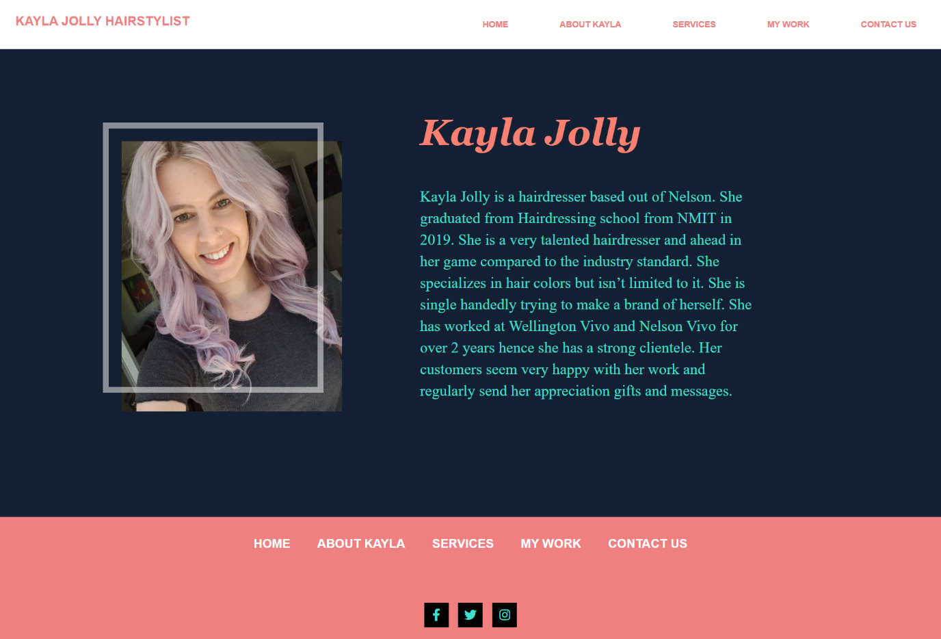

## Services Page

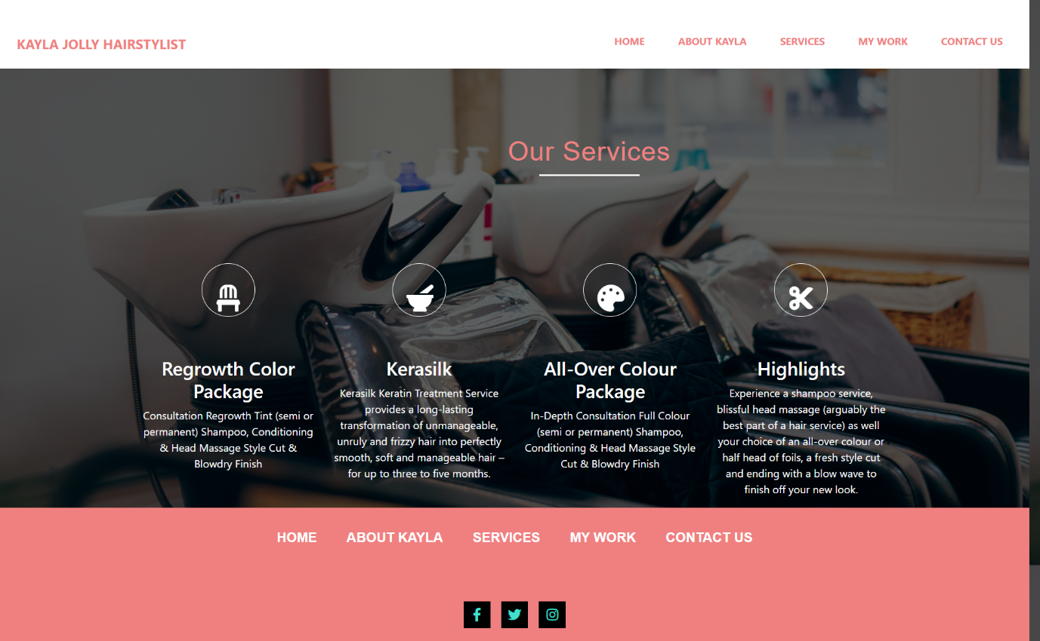

## My Work Page

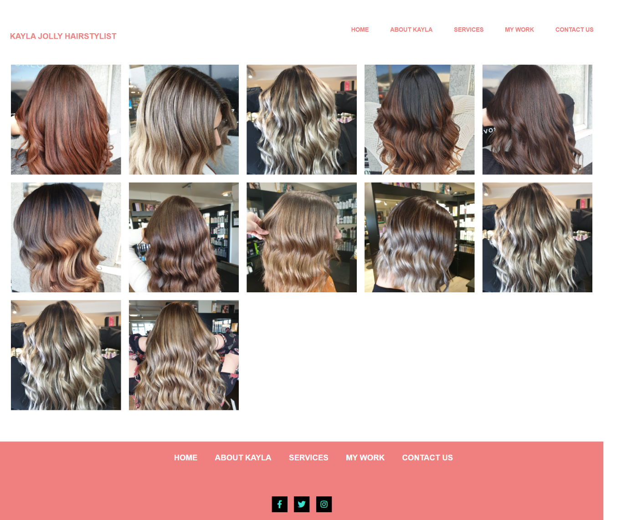

## Contact Page

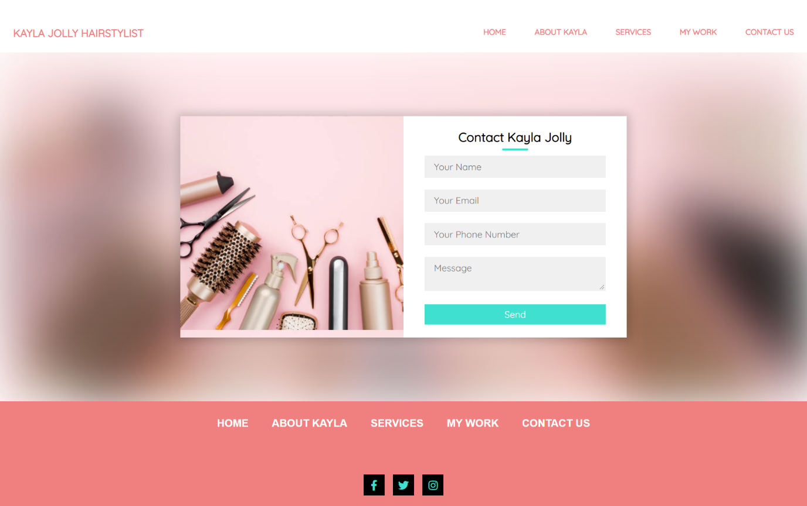

# Evolving Design

As you can see from the screenshots above, the website that I had designed in my first year was very basic since I was just understanding the concepts of HTML and CSS. I still like the layout of the website, but this time around I am going to revamp this template.

The website will have a scrolling banner which will consist of 3 hero images. Below are the images I intend on using.

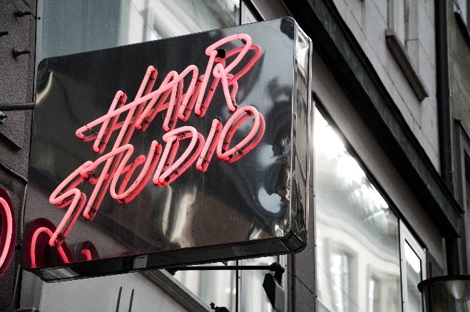 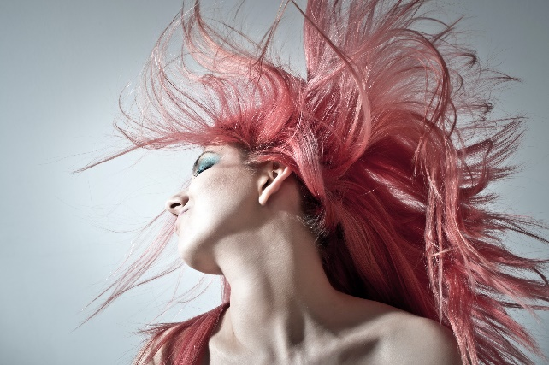

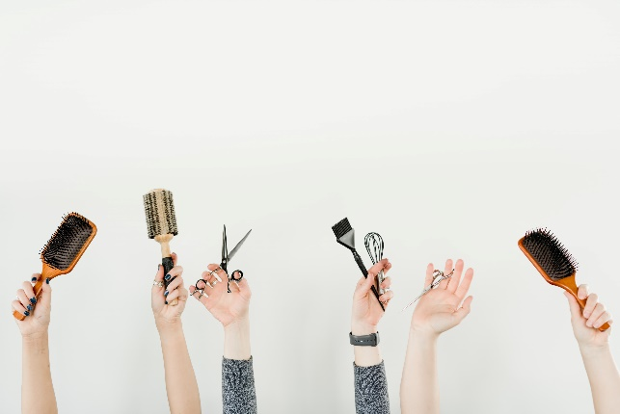

# Image

Out of the 3 hero images, the first hero image that I will have on the banner would be the this one

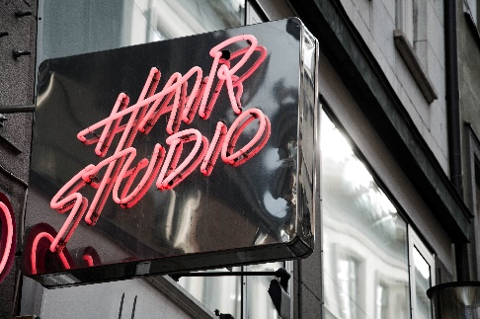

The reason I will have this banner image as the 1st hero image is because it will sit perfectly with the Turquoise and the logo, as it also has the pink color of the brand. This image will help with the impact of the home page. The image clearly helps understand what the website is about the moment you land on the home page. One of the most important things I have learned in web development is that people do not like reading much. The more text the sooner you lose your audiences, hence try to convey your message using more picture and less text, it is not always easy especially when you’re building a website about a construction company, but it can be done much better when you’re working on a fashion brand or even a hair dressing brand.

# Typography

I have always been confused with what font to use for the website, in my experience I have always tried to keep it simple, but I think for this website we need to be a bit more modern hence I have looked at quite a few fonts, but I am sure my mind will change again as the website evolves and takes it’s shape. I am not going with Sans-serif this time even though I know it looks modern.

As of now these are the fonts I would be working with :

Generic Font Family – Serif

Font Name – Georgia

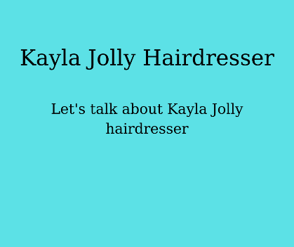

I will play with the font weight and style of the font to make it nicer on the website.

# Composition

I had the most difficult time coding in Neocities, after a few attempts I lost my patience and decided to move to Visual Code, since that is something I know how to use and how to code in, I did not just move to code but I also changed the concept of my website, from making a website of Famous Cities which I don’t really have any basic knowledge about, I decided to build something that is meaningful to me.

I do struggle with alignments especially in HTML, but that is something I look forward to working hard on the most. I know the content hierarchy of my website and my entire focus for this class is going to design a flawless design which is easy to use and visually appealing. My focus is going to be to keep the navigation of the website as predictable for my users as possible.

# Final Design

I do have a few mockups of what the website pages will look like, although I will be making heaps of changes to these mock-ups as well. I built these in my second year of web, and I was quite proud of how much my designing has improved but coding these using React and making them work was the hardest part, but for this website I would be making these designs in HTML and CSS only. I will change quite a few things, but I do consider this template to be a modern one and will try to keep the new template close to this one with some major changes.

I would be adding a booking system to this design, I would also be changing the footer. The new logo will be embedded into this design.

## Copy

The content of the website will be very simple infact I have all the content written down for the website, and just need to change a few things to make sure I am covering everything expected by the client. Usually I would have my client supply the content for the website but since this website is for my partner I don’t mind doing the extra work.

## Home Page

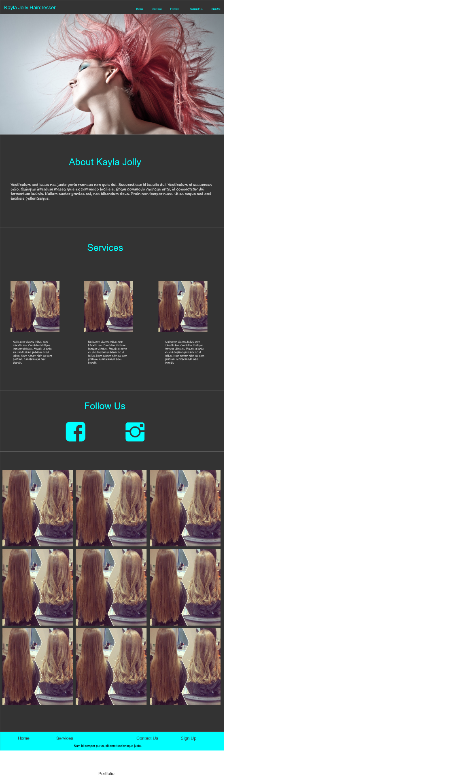

## Portfolio Page

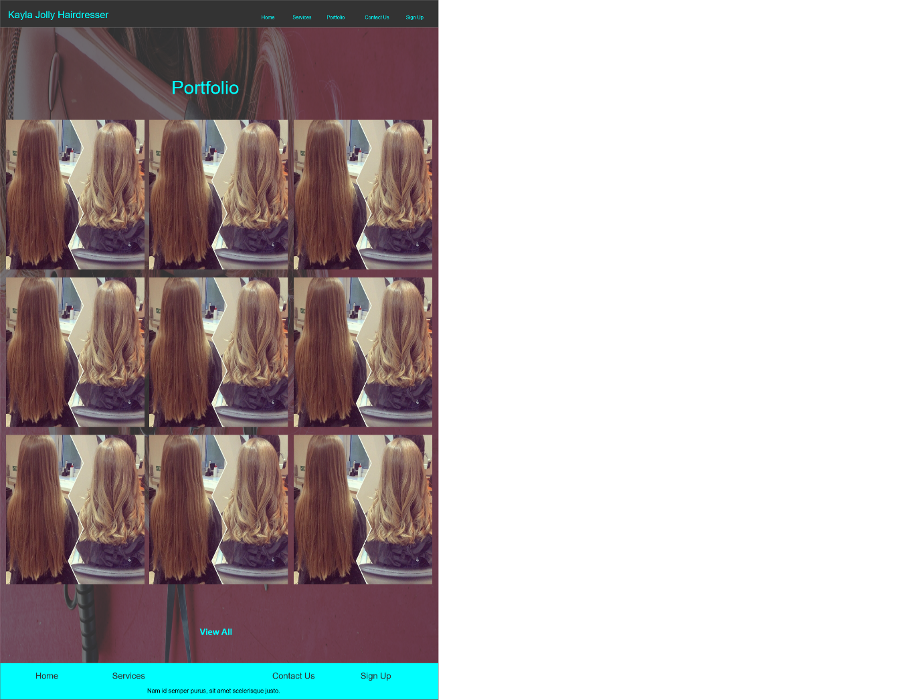

## Services Page

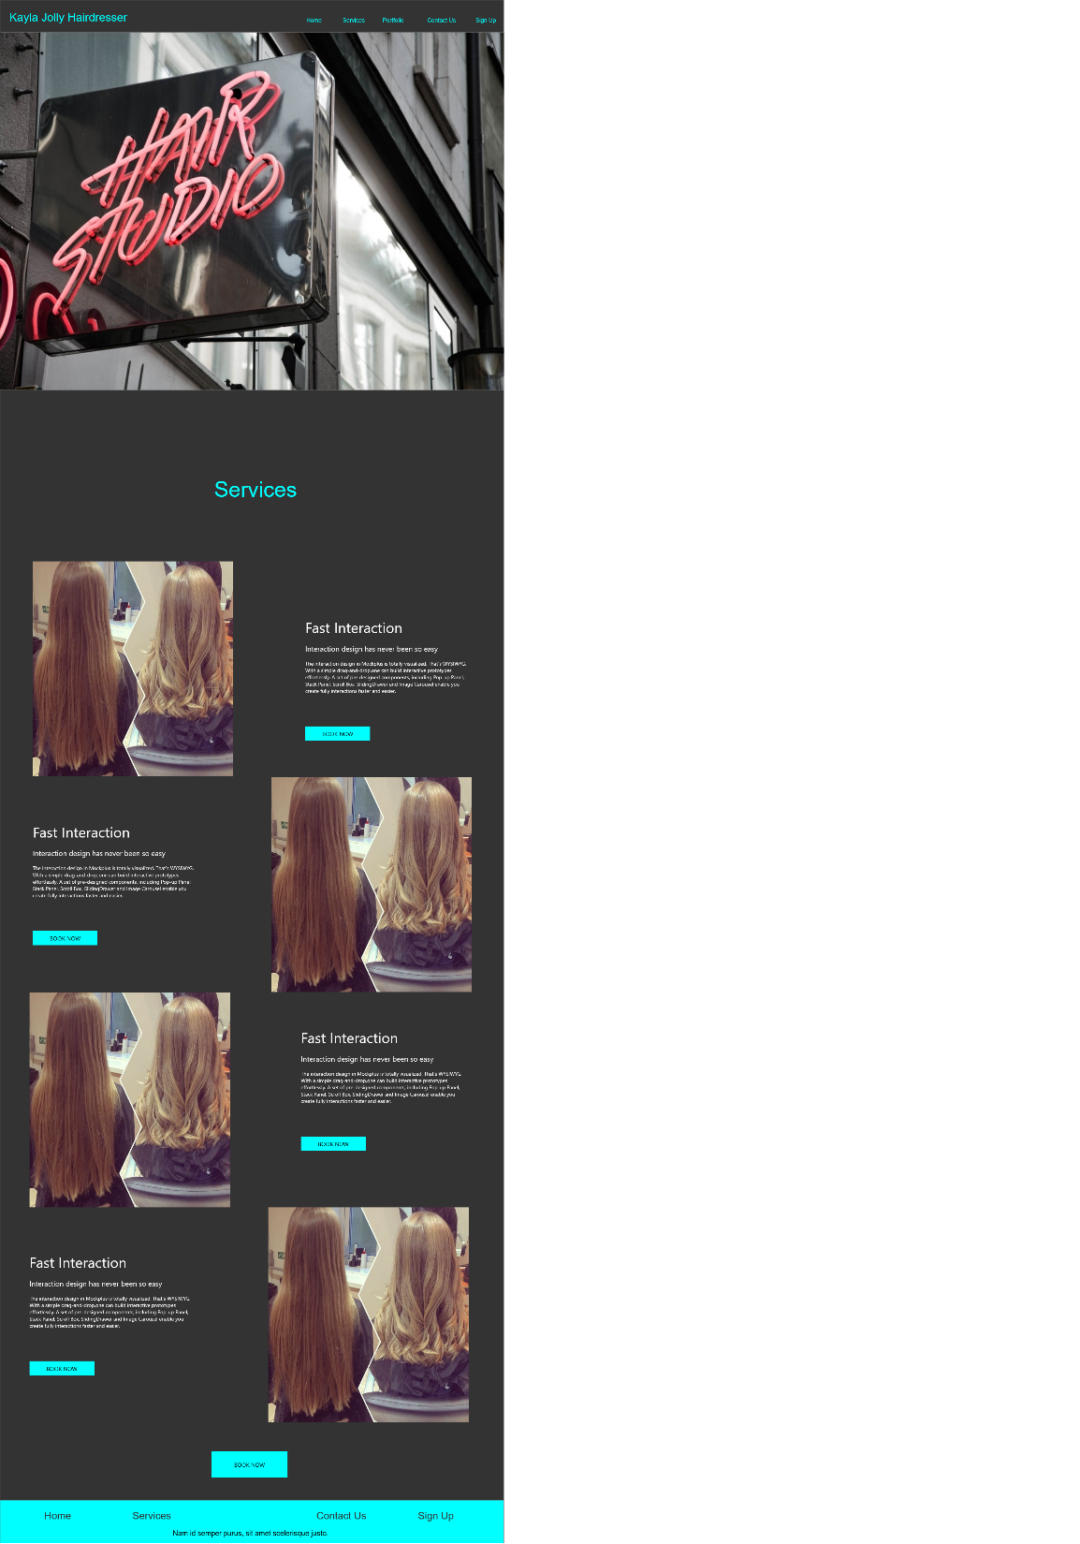

## Sign-up Page

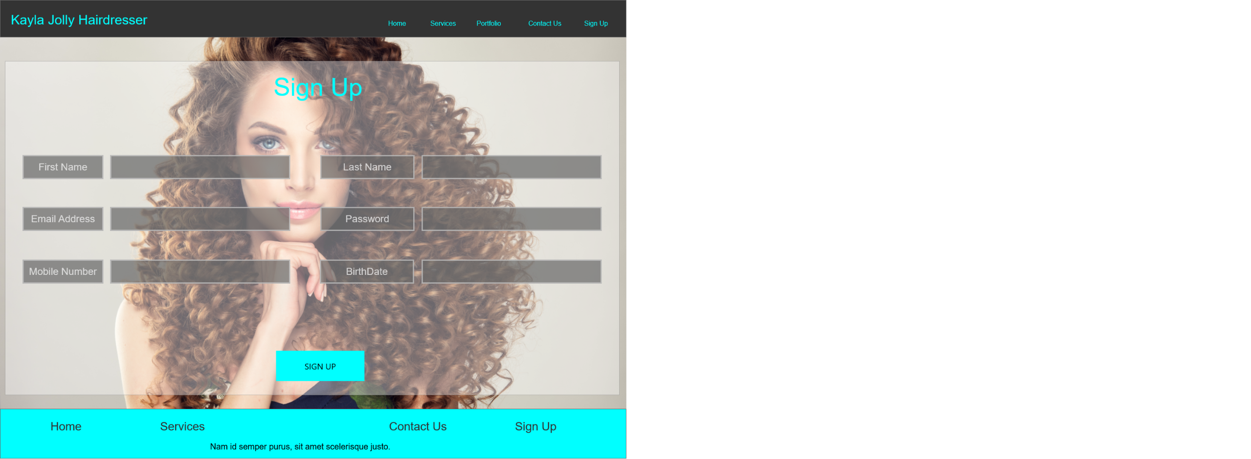

## Contact Us Page

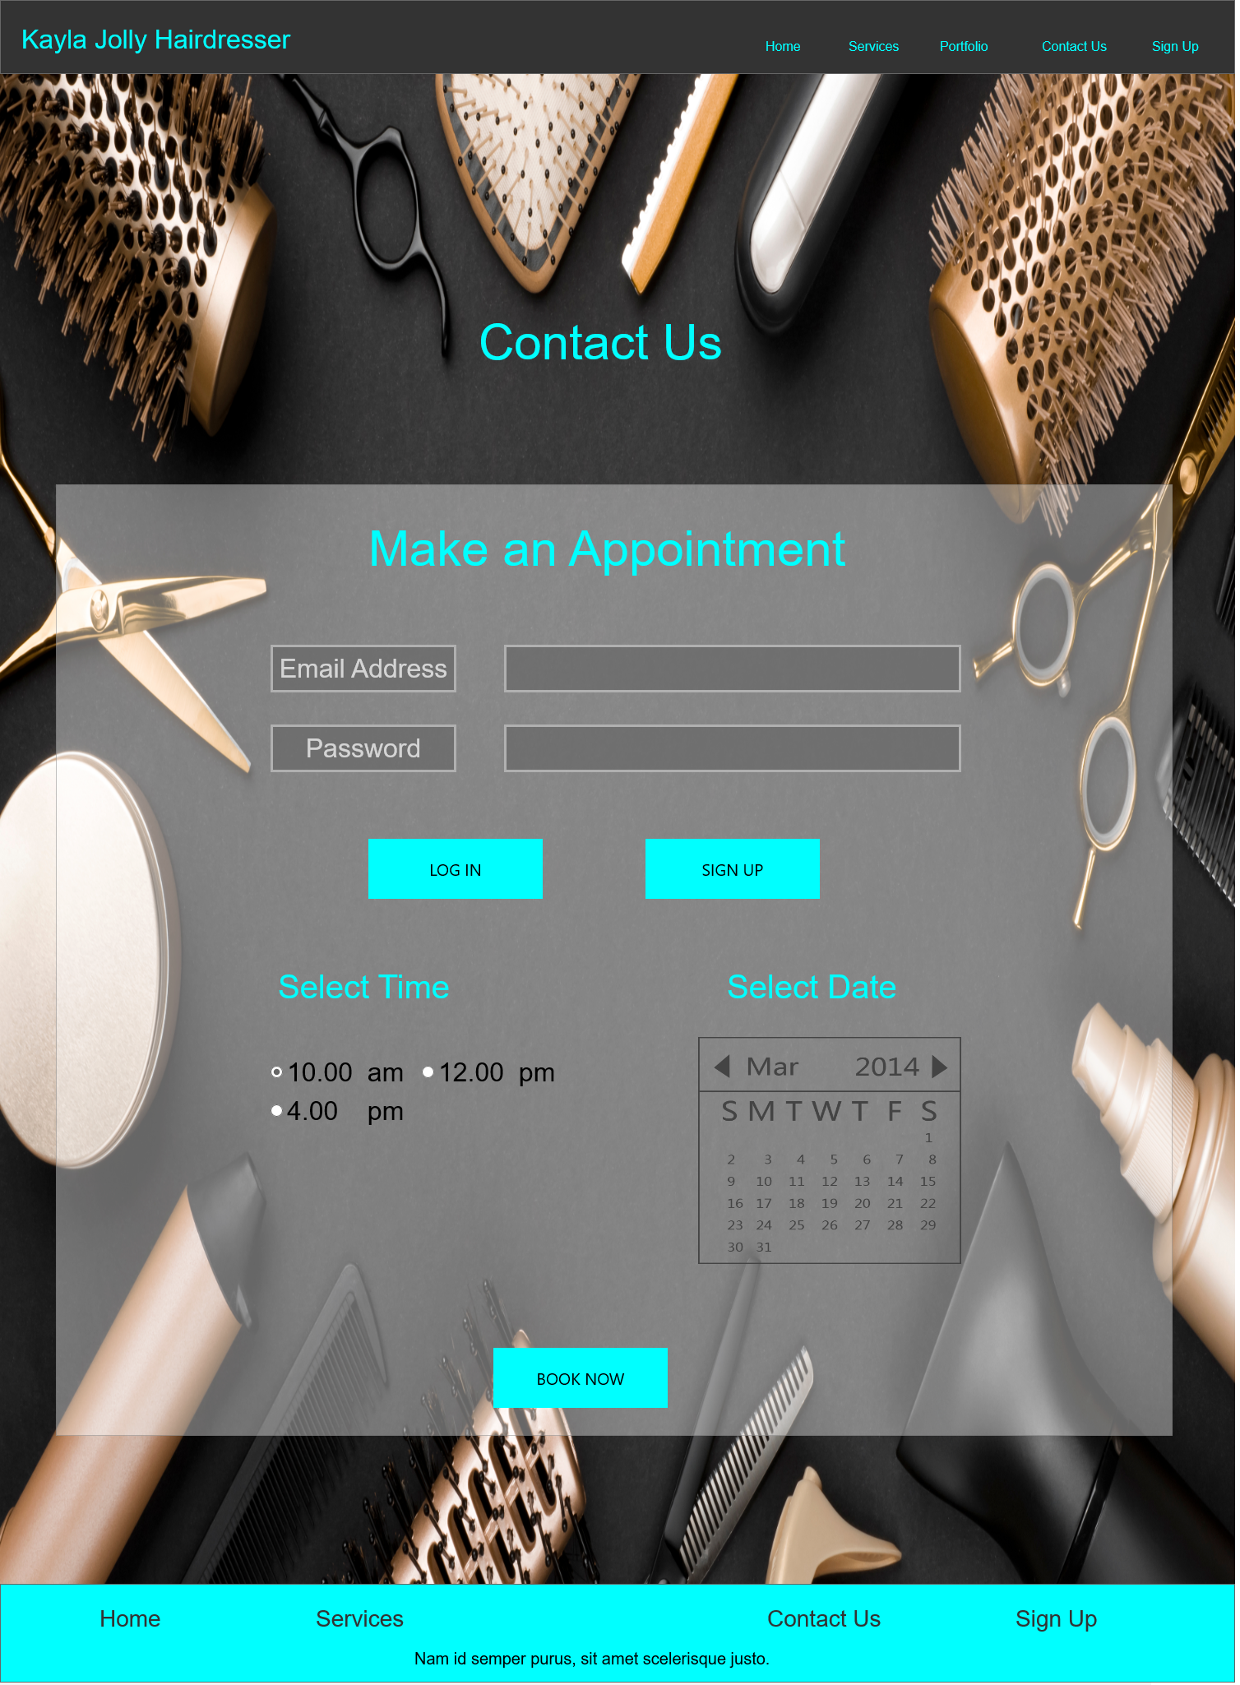

## Splash Page

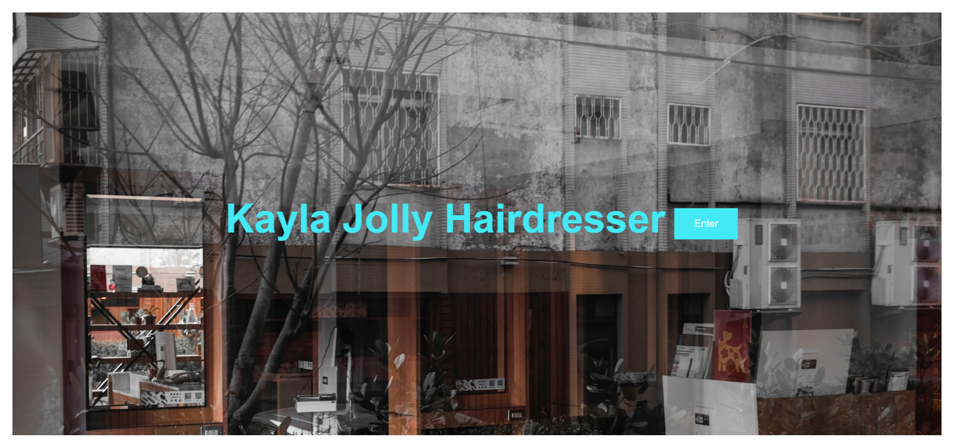

This is the splash page for the Kayla Jolly Hairdresser website, I do have some trouble moving the button under the text, but I could not figure out how to change that, maybe I will get my tutors help on this one. Before the splash page appears, an animation runs on the screen which I found to be cool, I found this piece of code on YouTube and instantly knew I wanted it on my website for my splash page.

# Future

I want this template that I am building in this course to be the final design for the Kayla Jolly Hairdresser website, I am going to make sure that I get all the elements right and design this website in such a way that it will be easy to navigate on the website, book an appointment, check out Kayla’s work and also follow her social media pages.

I am learning things in this course which we skipped in the first year which are the basics of web development I am thankful that I get to learn these things as you cannot build something concrete if your base is weak.

# References

DJ RAV UK. (2020, May 10). *Website Splash Screen with HTML and CSS*. <https://www.youtube.com/watch?v=8LkQSzNhlN0&t=2s>